Marketing Campaign Analysis
- Project Overview
The core objective of this project is to conduct a comprehensive performance analysis of digital marketing campaigns.
The dataset includes multiple campaigns across channels (Google Ads, TikTok, Instagram, Email, and Facebook), targeting different customer segments.
By leveraging data analytics and Power BI visualization, the project aims to identify high-performing campaigns and evaluate conversion efficiency.
Analyzing Marketing Campaign Data to understand performance, and identifying the Best Campaigns based on data-driven KPIs.
- Problem Statement
Businesses often struggle to allocate their marketing budgets effectively across multiple campaigns. Without a data-driven approach, it becomes difficult to distinguish between campaigns that generate real profit and those that lead to financial losses.
Additionally, variations across customer segments and countries can significantly impact campaign performance, making manual analysis inefficient and unreliable.
This project addresses the need for a structured and data-driven evaluation of Campaign Effectiveness

- Project Objectives
- Performance Benchmarking: Identify top-performing campaigns based on CTR, Conversion Rate, and Revenue
- Profitability Analysis: Calculate ROAS and ROI to determine profitable vs. non-profitable campaigns.
- Conversion Optimization: Analyze user behavior and identify factors driving conversions.
- Campaign Comparison: Evaluate performance across customer segments.
- Key Metrics (KPIs)
- Impressions – Total number of views
- Clicks – Number of users' interactions.
- CTR (Click-Through Rate) – Engagement level.
- Conversion Rate – Effectiveness of campaigns
- CPA (Cost Per Acquisition) – Cost efficiency
- Revenue – Total generated income
- ROAS (Return on Ad Spend) – Revenue vs. cost.
- ROI (Return on Investment) – Overall profitability
- Methodology
- Data Cleaning & Transformation: Using Excel and Power Query
- Exploratory Data Analysis (EDA): Identifying trends, patterns, and anomalies.
- KPI Calculation: Using DAX in Power BI
- Visualization: Building an interactive dashboard with filters and drill-down features
- Expected Insights
- Identification of high-performing and underperforming campaigns
- Detecting campaigns with high CTR but low conversion (inefficiency)
- Discovering opportunities to reduce costs and increase revenue.

- Expected Deliverables
- Interactive Power BI Dashboard including:
  - KPI overview (CTR, ROI, Revenue, Conversions)
  - Campaign performance comparison.
  - Filters (Country, Customer Segment)
  - Drill-down analysis.
- Comprehensive Data Analysis Report
- Data Modeling
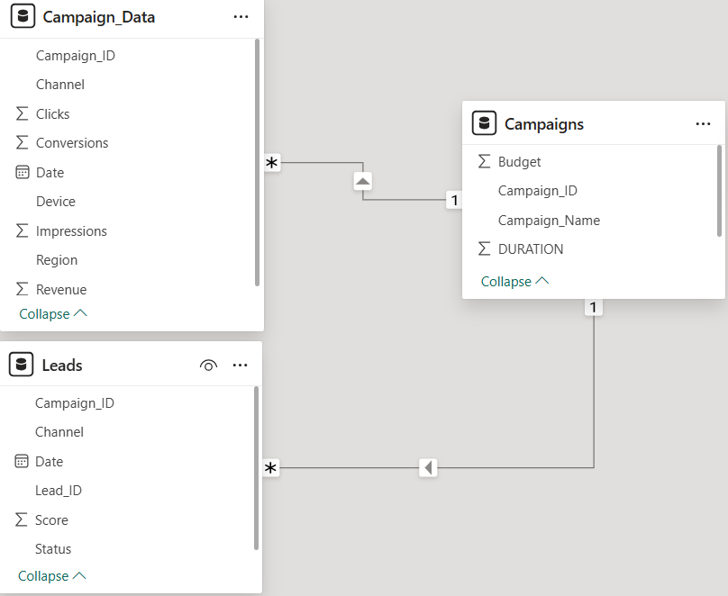
- Project Plan:

Phase | Task | Duration
Phase 1: Planning | Defining KPIs & Business Requirements | 3 Days
Phase 2: Data Acquisition | Data Collection (Google Ads, CSVs, APIs) | 4 Days
Phase 3: Data Preparation | Data Cleaning & Transformation (Power Query) | 6 Days
Phase 4: Data Modeling | Building Relationships & Creating DAX Measures | 5 Days
Phase 5: Analysis | Exploratory Data Analysis (EDA) & Insights | 5 Days
Phase 6: Visualization | Building Power BI Dashboards & Reports | 7 Days
Phase 7: Evaluation | Testing Accuracy & Final Review | 3 Days
Phase 8: Documentation | Final Report & Presentation Preparation | 4 Days

